B1 B2 B3 6 Mark Questions

Taken from the higher paper (one page per year)

Topic which have appeared since 2012:

- Genetic Testing – Implications
- How vaccines work
- The Nitrogen Cycle
- Immune system response (white blood cells etc.)
- Drug licencing
- Stem cells
- Environmental Indicators (named examples needed)
- Clones
- Blood Pressure
- Evolution (natural selection included)

January 2012

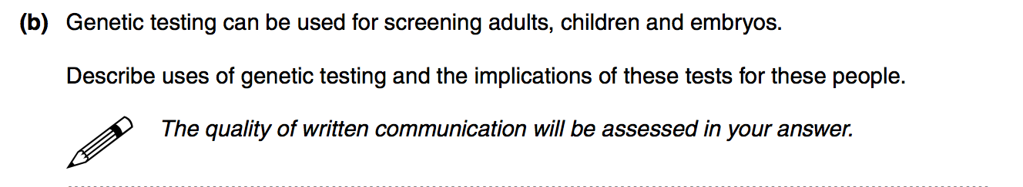

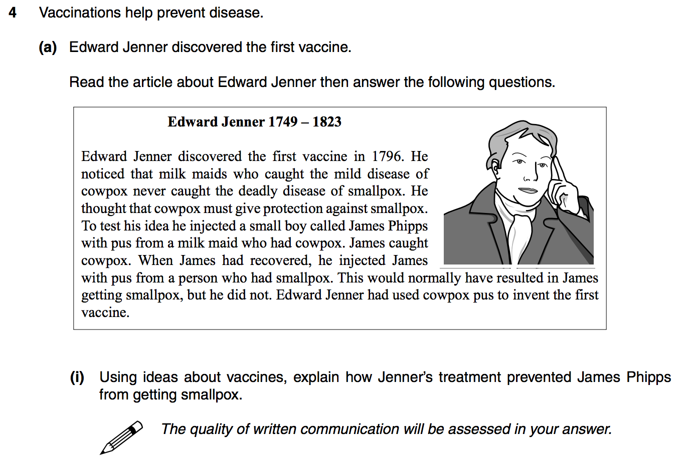

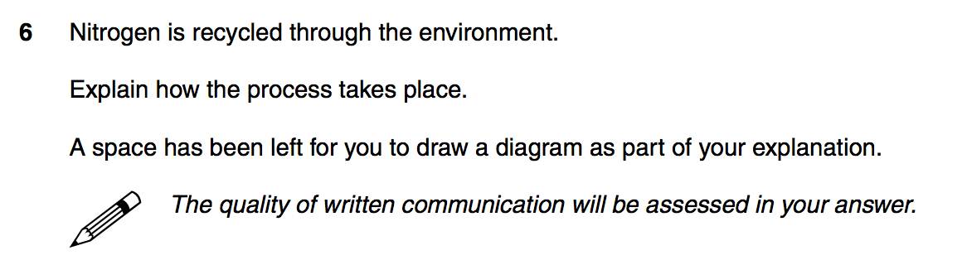

June 2012

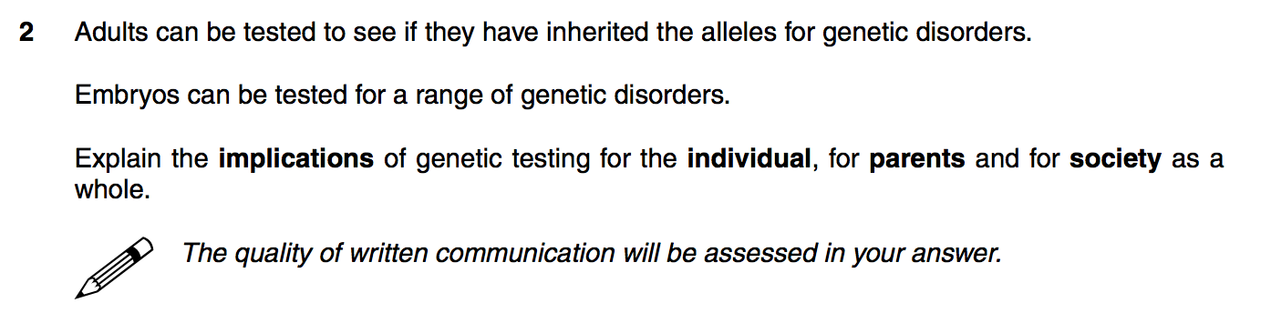
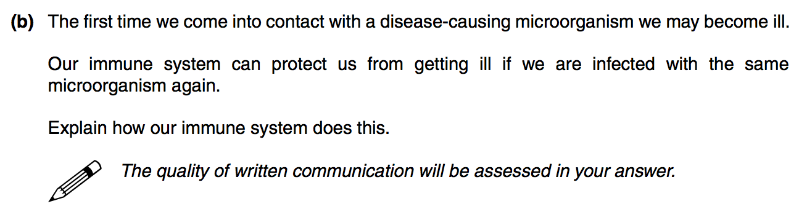
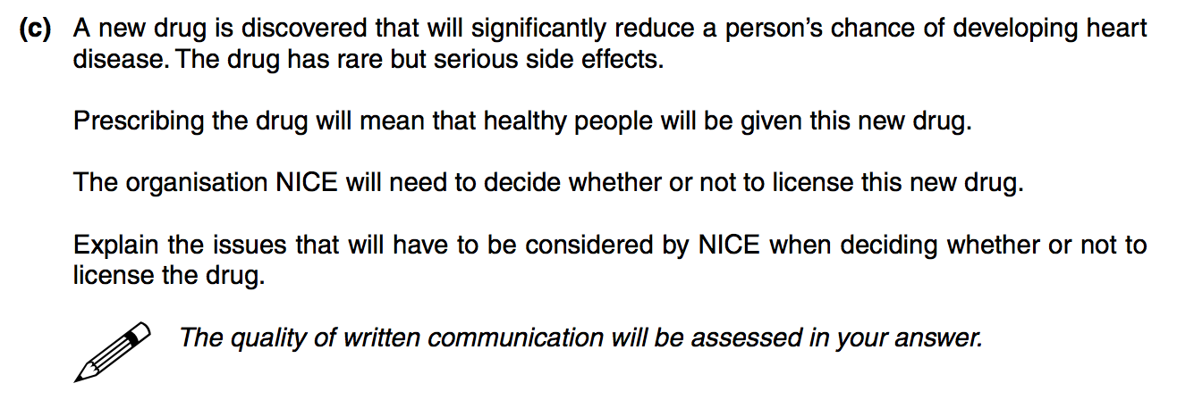

January 2013

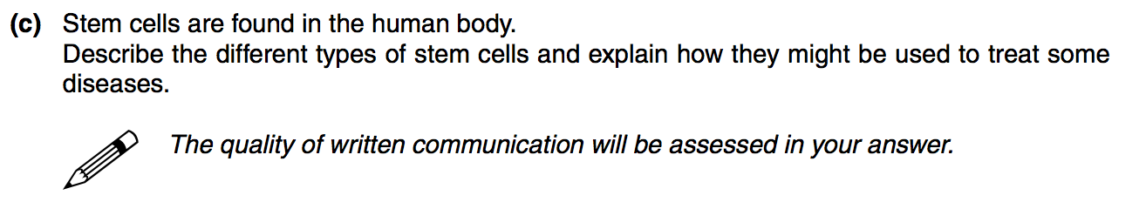

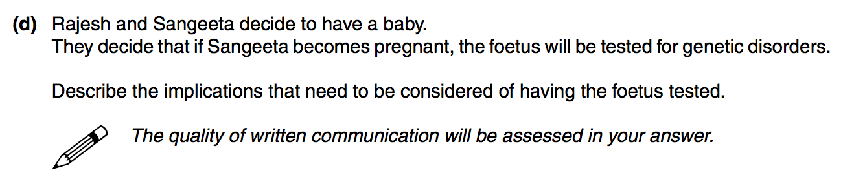

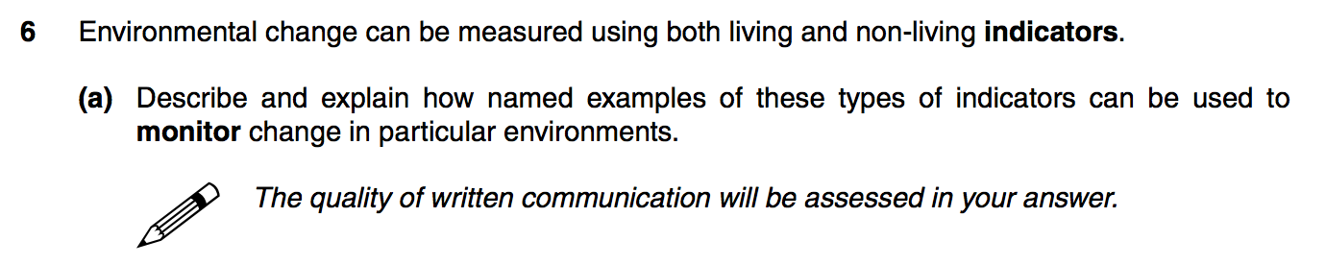

June 2013

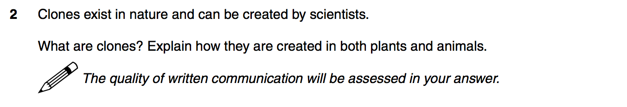

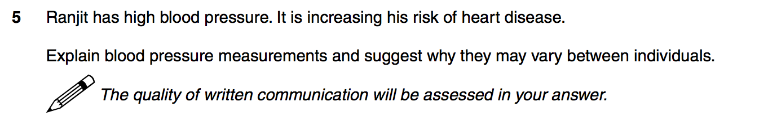

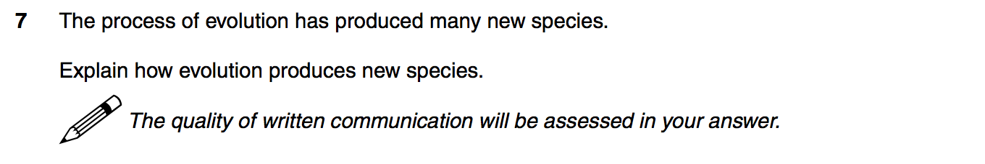

June 2014

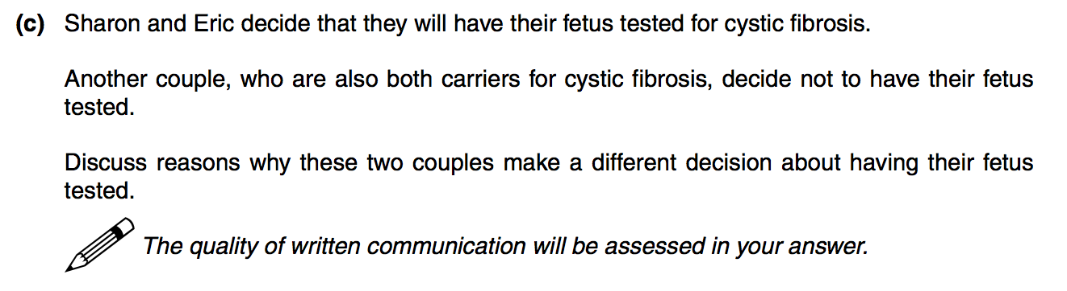

Question 5B ignored as it requires information from several previous questions.

