C1 C2 C3 6 Mark Questions

Taken from the higher paper (one page per year)

Note:
Following the presentation of the Biology B1 B2 B3 paper, the exam board seems to be drifting towards questions more focused on inference rather than actually stating what they want you talk about. Be one step ahead and look out for this!

Additional note:
I’ve left out the January 2012 as these questions had a large amount of explanation before hand and so were hard to put onto one page. They’re available online though if you want to take a look!

Topics which have appeared since 2013:

- Earth’s early atmosphere
- Fractional distillation
- Risks of plasticisers
- Reactions in a car engine/combustion
- Properties of polymers
- Dangers of plasticisers
- Correlations and trends
- Chlorination

June 2012

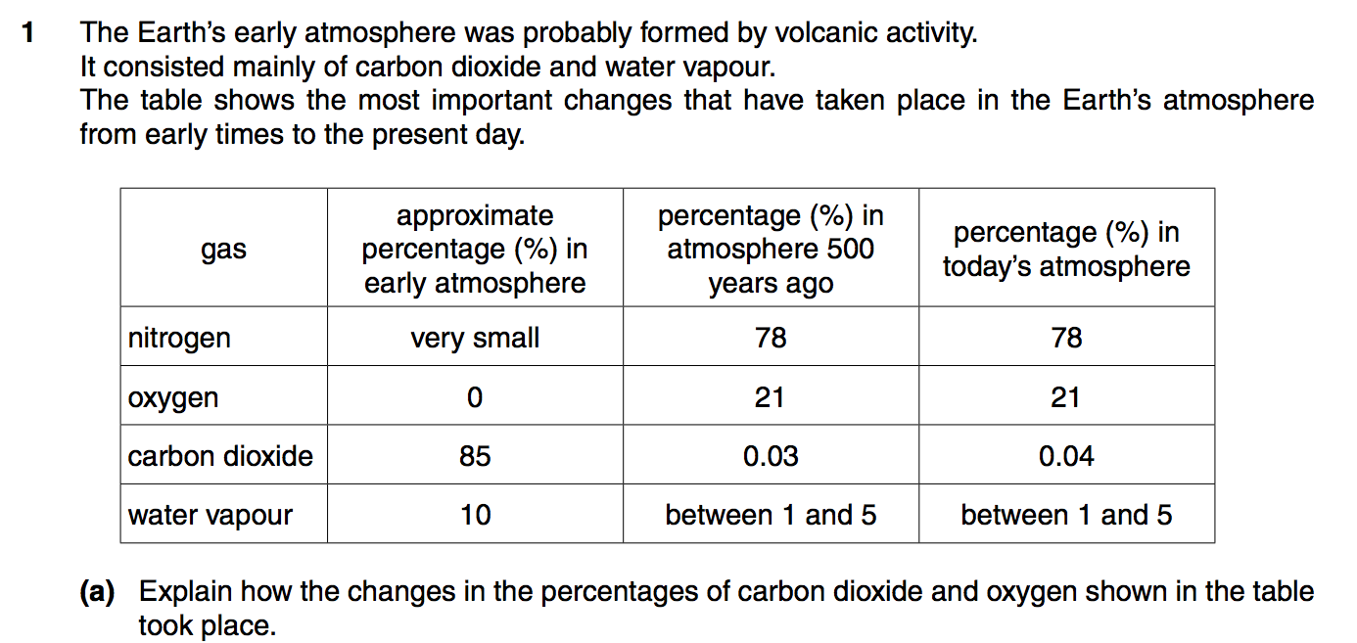

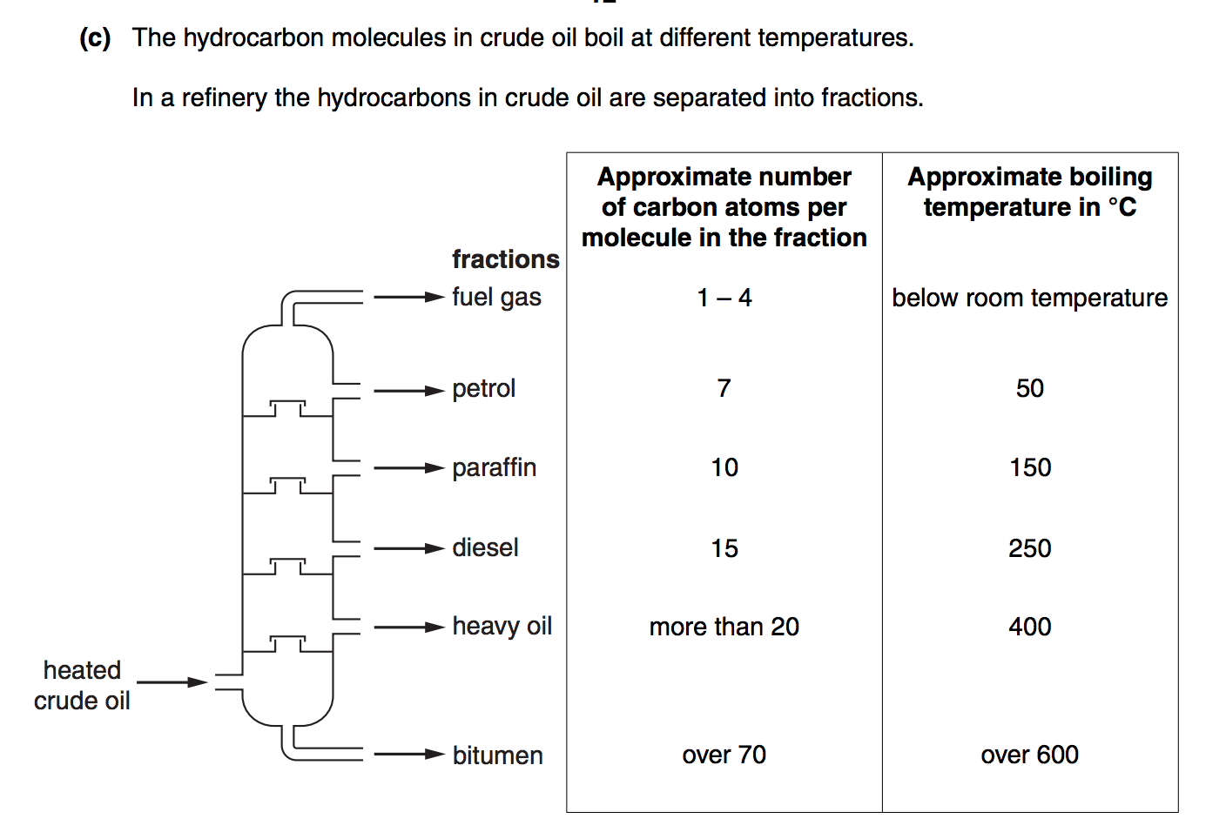
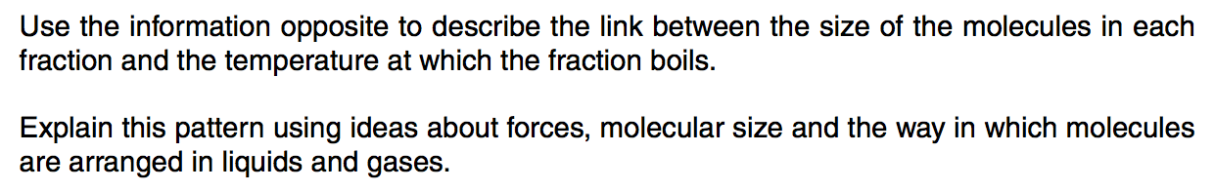

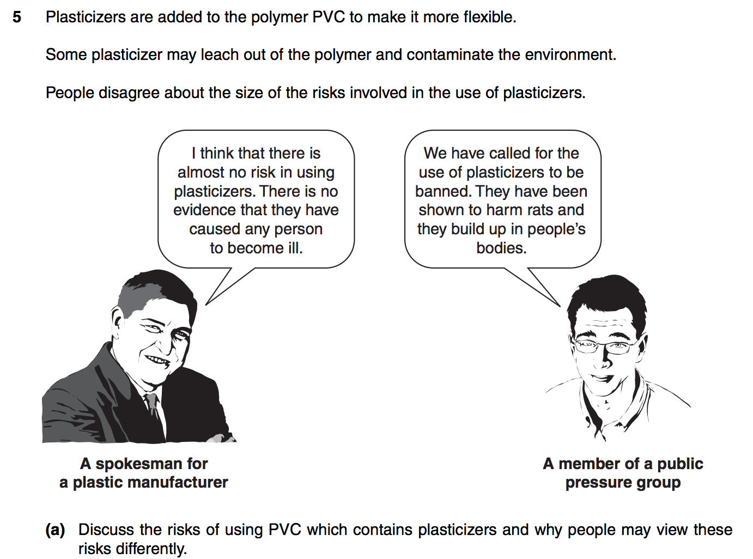

January 2013

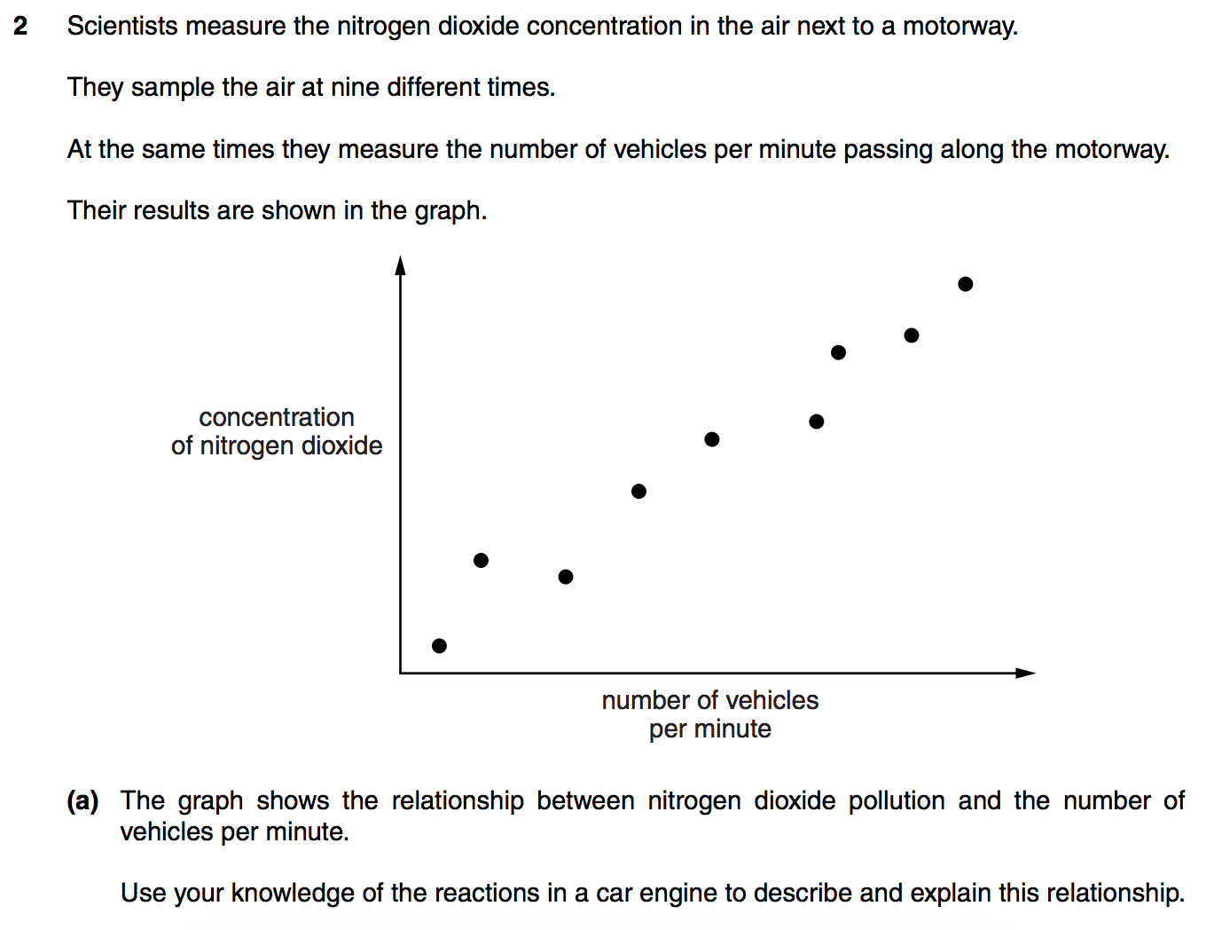

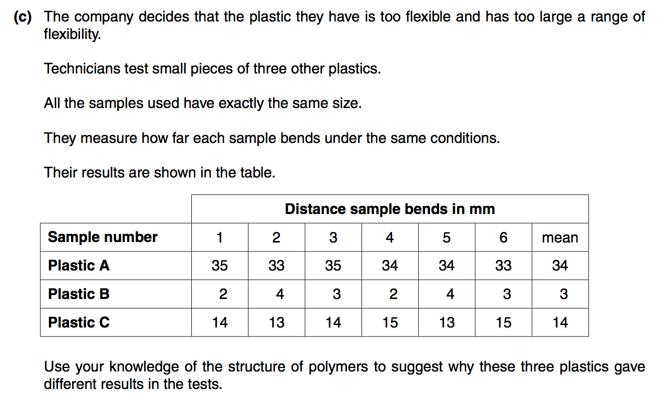

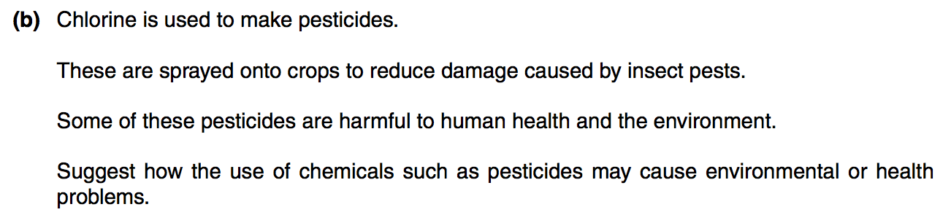

June 2014

